Rule # 2 of the 2023 WCLA Rulebook states, “The exhibitor must continuously and personally feed and care for his/her animals under the supervision of their CEA or AST.”

Rule # 3 of the 2023 WCLA Rulebook states, “Feeding projects on property other than the school barn facility or exhibitor’s premises must be approved by the CEA, AST and the WCLA Board of Directors.”

We understand there are certain instances when the livestock may be located at a facility other than a school barn or the exhibitors premises and is outside of the direct care of the livestock exhibitor, their family, or their supervising County Extension Agent/Agriculture Science Teacher. These instances and the requested alternate location must be approved as noted in Rule #3. This form is to serve as an approval process for WCLA validated livestock projects requesting to be located at an alternate facility, outside of the care of the exhibitor and/or their family members for different reasons.

This form must be signed by all parties listed below. Submission of request does not ensure the request will be approved. Please know you may not relocate livestock until you have received full approval from the CEA, AST and the WCLA Board of Directors. WCLA validated livestock projects outside of the direct care of the exhibitor, family member, or CEA/AST could result in disqualification as outlined in Rules #2 and #3.

Steps for completing this form:
1. Livestock exhibitor family is responsible for initiating form, completing all information, and obtaining signatures required to submit to the WCLA Board of Directors.
2. The exhibitor family should send this form to the supervising CEA/AST for approval signature.
3. If the CEA/AST approves of the request, they send the form to the WCLA Board of Directors.
4. If the WCLA Board of Directors approves, the WCLA Livestock Superintendent will check the box for approval and sign the request as proof of the boards approval. If the board denies the request, the WCLA Livestock Superintendent will check the box for denial. The exhibitor family will be notified of the board approval or denial.

The following WCLA validated livestock projects are requesting to be located at a location other than a school barn facility or exhibitor’s premises, outside of the direct care of the livestock exhibitor and/or their family members. Please fill in the information below:
Name of Exhibitor(s):
Species:
WCLA Validation Tag Numbers:
Reason for Livestock Alternate Location Request: .

Name of Third-Party Providing Location/Care of Livestock:
Phone Number of Third-Party Providing Location/Care of Livestock:
Physical Address Requested for the Livestock at Third Party:
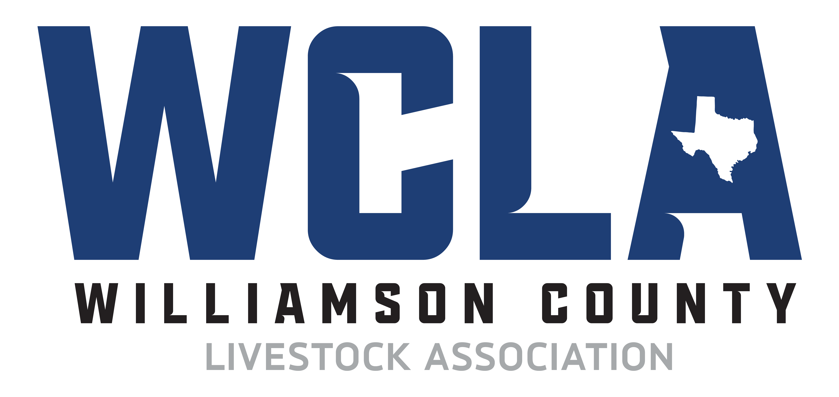

2023 Williamson County Livestock Association
Alternate Housing of Livestock Request Form
Signatures to Obtain Before Seeking Approval
1. Exhibitor(s): Date:
2. Parent or Guardian: Date:
3. Third-Party Providing Care of Livestock: Date:
(By signing this form, you authorize that the the division superintendent may check the exhibitor’s project at any time after tag-in until show time. He or she must be accompanied by the County Agent and/or Agricultural Science Teacher and the Parent(s) or Guardian of the exhibitor on premises you own, lease, or control at any time with or without prior notice.)

Signatures Needed for Approval
1. Supervising CEA or AST:
2. WCLA Livestock Superintendent:
(Livestock Superintendent signature verifies majority vote of the WCLA Board of Directors approval)

- Approved Date:
- Denied Date:

Denied requests should be emailed to the CEA and AST immediately upon decision.

