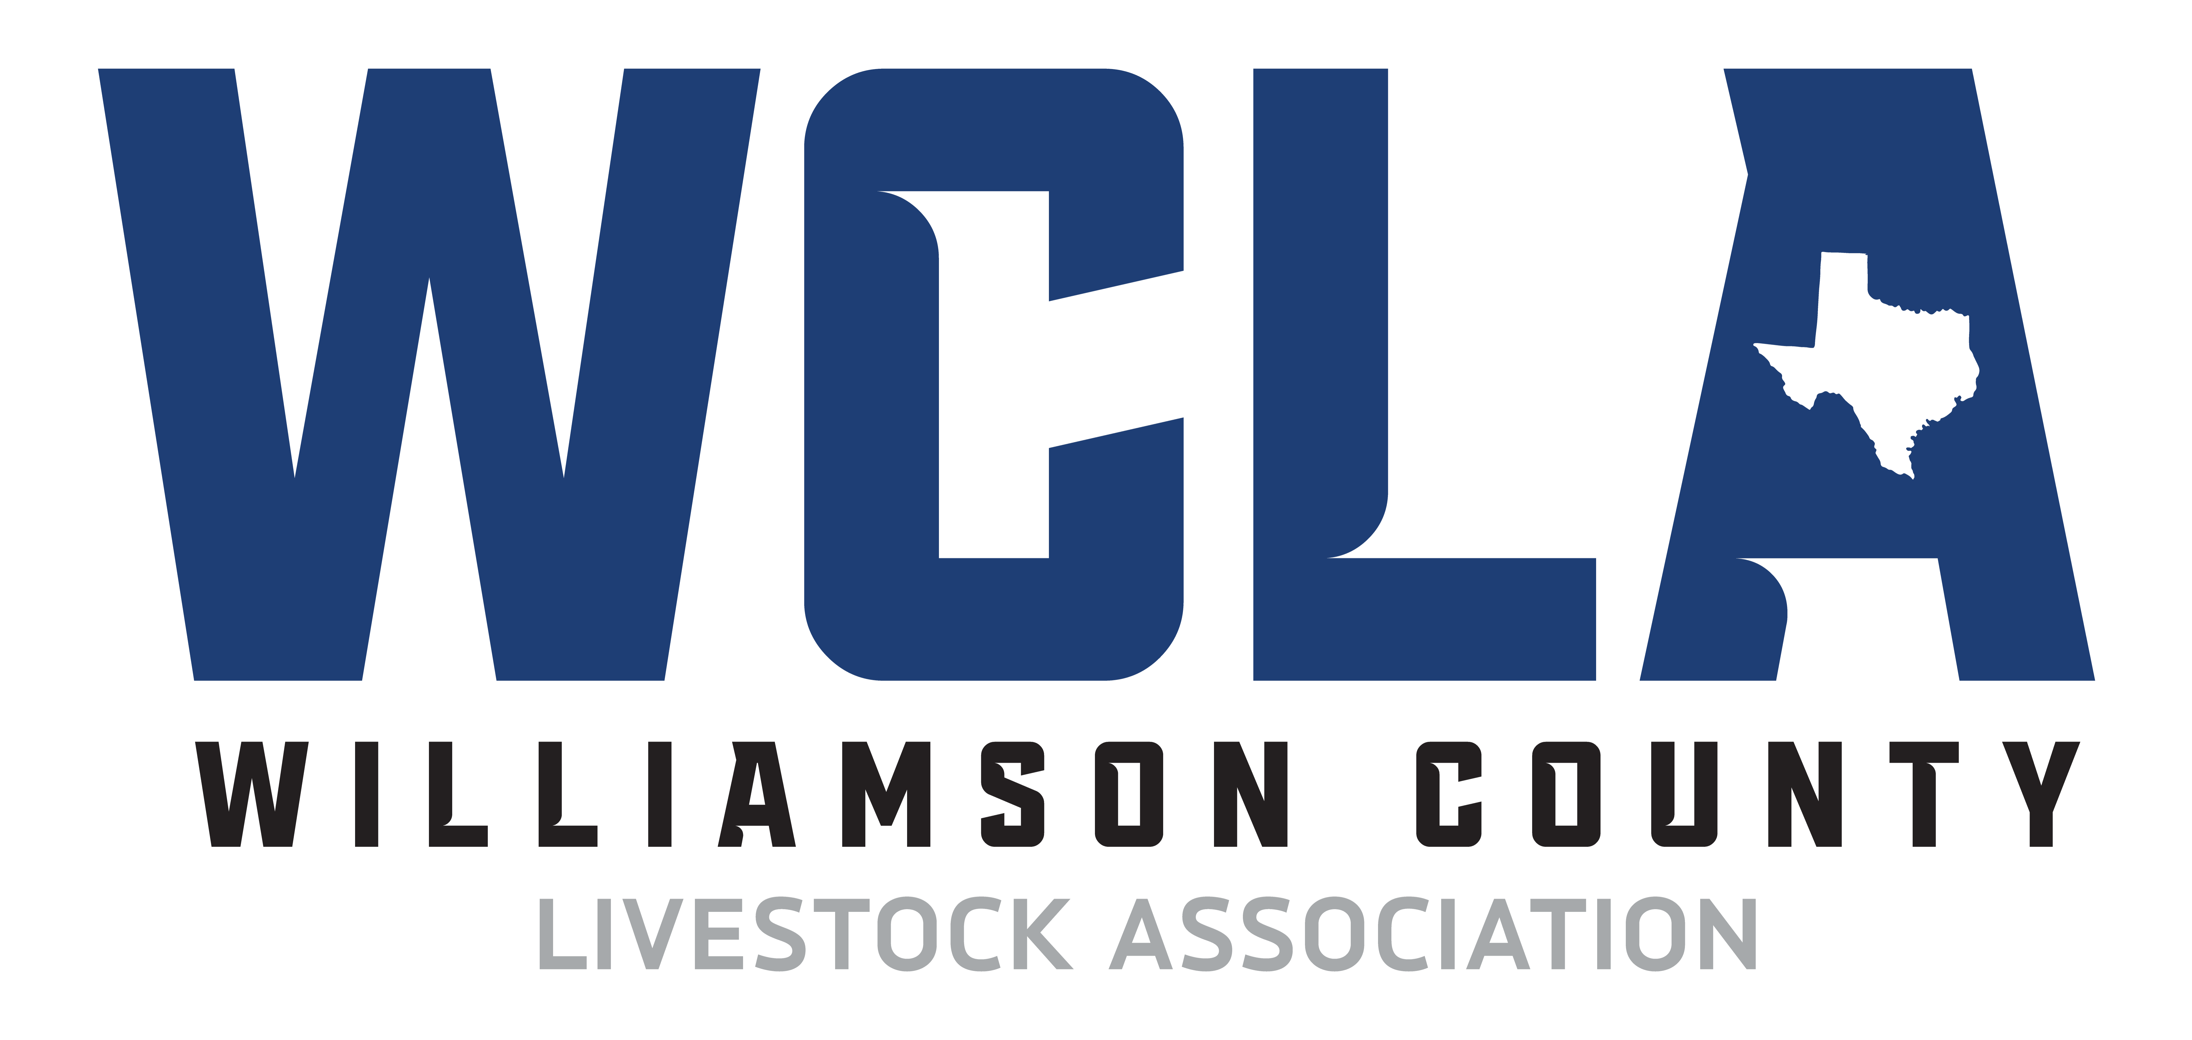

Meeting Minutes

8/28/23
Call to Order
Brad Noack called to order the meeting of the Williamson County Livestock Association at 7:08 pm on August 28, 2023, at Moravian Hall in Walburg, TX.
Roll call
The following persons were present: Brad Noack, Wayne Sanders, Montgomery Raesz, Paul Boff, Mike Ondrasek, Richard Sells, Daniel Knippa, BJ Simpson, Dustin Davidson, Brad Adams, John Faske, Colby Doherty, Blake Henderson
Guests: Heather Faske, Patrick Phillips
Financial Report: R Bank Checking- $108,986.71
R Bank Money Market - $51,576.84
R Bank Scholarship Money Market - $4,112.97
R Bank Savings - $41,926.17

Williamson County Livestock Association

P.O. Box 530 Georgetown, tx 78627

wcla.bod@gmail.com
Committee Reports:
- Scholarship - Committee Chairman - Colby Doherty
- Applicants submitted applications and were scored. A total of 14 scholarships were awarded.
- Scholarship Funding:
    - Doug Vrabel Memorial Scholarship - 1 scholarship @ $2,500.00
    - WCLA Scholarship(s) - 13 scholarships @ $1,250.00
- Livestock -
- Superintendents:
  - Livestock - Wayne Sanders
  - Poultry - Montgomery Raesz
  - Rabbit - John Faske
  - Goat - Richard Sells
  - Lamb - Matt Suchomel
  - Swine - Colby Doherty
  - Cattle - Mike Ondrasek
  - Media - Paul Boff
  - Award - Blake Henderson
  - Facility - Brad Adams
  - Fundraising - Donnie Smith
  - Scholarship - Colby Doherty
  - Jr. Steering - Matt Suchomel
- Judges:
  - Rabbit Judge – Mary Jo Terry
  - Goat Judge – Derrick Brown
  - Breeding Goat/Lamb – Derrick Brown
  - Lamb Judge – Sierra Nauman
  - Poultry Judge – Jacob Leopold
  - Cattle – Austin Nauman
  - Swine – Kelton Mason
  - Breeding Swine – Kelton Mason
- Validation -
- DNA Testing – Animal ID -
  - All champions & reserve champions
    - Pull hair at conclusion of champion drive
  - Pull random test from showmanship classes
  - Retags (all) shall have DNA hair pulled
  - Any protest that is brought to the committee will be tested. Samples will pulled after protest fee paid.
  - DNA Samples matched prior to checks being issued. All samples matched for 2022 show.
- Validation operations:
  - 2023 Steer Validation DNA samples will be pulled at state validation time that the county extension office sets. Need rules acknowledgment forms filled out at same time.
  - 2023 WCLA Show Market rabbit tattoo date to be major show entry night or last day of regular entry for WCLA to be announced at a later date.
- Facility -
- Show Schedule details
  - Saturday, December 2nd through Sunday December 10th, 2023
  - Placing panels on Friday December 1st for barn setup Saturday December 2nd.
  - Friday December 8, 2023 barn teardown, prep for sale / auction on Saturday. Need to review and adjust show schedule and show order for the week.
- Expo and review layout - Will stay the same until we get more panels.
  - Will we allow any vendors
    - Vendor Fee - Fundraiser donation
    - Supply Trailer – Yes, Stock Show Pros
- Need PA System - Mike Ondrasek
- Announcer - Scooter Dubec
- Scales - Rusty Morgan
- Awards -
- Need to awards for 2023 Show.
- New Herdsman Award for FFA Chapter or 4H Club presented to Glenn FFA.
- Youth Fair -
- No Report
- Social Media - Committee Chairman - Paul Boff
- Sharing of other groups fundraising efforts on WCLA social media page(s). If they support 4H/FFA youth at the WCLA sale, we will support them and share their information.
- Auctions -
- Online Auction a success.
  - Need dedicated working Internet / LAN hookup for auction table and stage. Had to use hot spot. Sent After Action Report to Expo.
  - County server / firewall doesn’t allow for direct connection to LAN for internet usage. Have to plug in wireless router in order to access internet online.
  - Look into other online auction platforms
- Junior Steering Committee - Committee Chairman - Matt Suchomel
- Discuss Junior Directors and possible Top Hand Awards need submission at next meeting.
- Legal
- No Report
- ShoWorks
- No Report
- Fundraising / Sponsor / Auction - Committee Chairmen - Donnie Smith
- Spring fundraiser planning ongoing. Spring fundraiser date is scheduled for Apr 15, 2023.
- Audit
- No Report
- 4-H Report
- No Report
- Show - No Report
- Trailers with Ramps can unload from the North area.
- Covered Breezeway will unload from East to West for trailers without ramps.
- Lamb & Goats will not be able to move in until noon on date set in future schedule.
- Poultry to unload in Covered Breezeway from East to West.
- Pull Electric drops from around bleachers
  - For blowers “sheep & goat” show, electric drops on outside walls of barn.
- Photography backdrop setup and operation: Chairman: Mike Ondrasek
  - New backdrop and logo design - Showtimes.
- Sponsor Signs:
    - Current
    - New
    - Show Ring
    - Setup, tear down and storage
    - Opening Ceremonies: Junior Steering Committee:
    - Flags
    - Anthem
    - Pledge
    - Prayer
- No Peewee class for 2023 breeding showmanship shows. Exhibitors must be between the ages of 9 (or 8 and in the third grade) and 19 years of age as of September 1, 2023 and have a quality counts number.
- We will have a future feeder’s showmanship for market shows: Lambs, Goat, & Swine only.
- Photographer for 2023 - Megan Dunn, MD Creations
- Animals (Steer) needs to be clipped prior to arriving.
  - Steer heads needs to be clipped, specifically polled breeds.
  - British Breeds need to designate breed showing under.
- No Wire Halters of any kind on any species.
- Drug Testing: Look into hiring outside entity to administer, monitor and test. Set up teleconference or tour to research. Need to review guidelines and set rules.
Old Business
- Follow up with Colby on new racks and panels.
- Tag order completed; sheep will have a sheep tag backing to make for more room inside the ears of the smaller eared lambs.
- Discussed using outside vendors possible for shavings.
- Review updates made from previous meeting to include additional breeding/commercial show rules, validation requirements and finalize rulebook.
- Discussion on fundraising and sponsors.

New Business
- Check on status of show ring panels and rack order update. Rusty has not responded.
- Tags have been received and need to be paid. Discussion on when to meet and build tag packages after cutoff date. Package tags up per School chapter 4H at noon 9/17.
- Discussion on Turkey order change in pick up date to Thursday 8/31/23.
- Discuss outside vendor possible for shavings.
- Discussed renewing contract with Williamson County Expo Center. Also discussed booking show weeks for 2024 and 2025 and trying to deconflict with school finals
- Discussed updated sponsor sheet.
- Will look at back drop to determine quality for reuse and possibly get new stickers for new sponsors.
- Discussion on breeding swine dates and class breaks be by weight vs age. Discussion on changing max weight limit to mirror market show.
- Montgomery Raesz motioned to change line (F) under Breeding Swine show rules to read “Pedigreed Breeding Swine must be born between June 1 and September 10, of the year of the show. All Breeding Swine will have a maximum weight limit of 280 pounds and will be subject to the same weigh back procedures and tolerances (10 pounds) as Market Swine.” and to update the weight chart to include the weight tolerances of 0 to 280 lbs for “All Breeding Swine”. Seconded by mike Ondrasek, motion passed unanimously.
- Discussed requiring a signature from AST/CEA/4H Leader on junior directors application for approval.
Motion to adjourn made by Brad Adams. Seconded by Wayne Sanders. Motion passed. Meeting adjourned at 8:23 pm.

Minutes submitted by: Brad Noack

